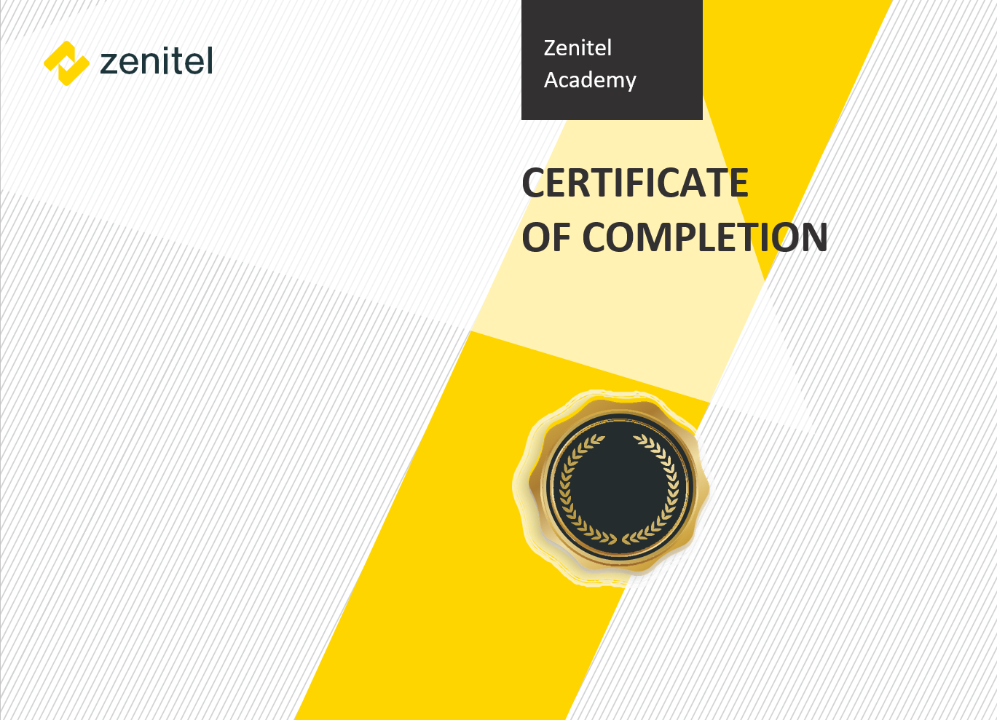
Issued:
11 June 2024
Completed E-learning Course
for successfully completing the course
Zenitel Connect Pro Professional Diploma
This certificate is proudly presented to
Sergio
Mendes

